Task 19

Q1.use locators for guvi register page

Navigate to <https://www.guvi.in/register>

Locate the web elements using Locators

id

className

tagName

cssSelector

xpath

Script:

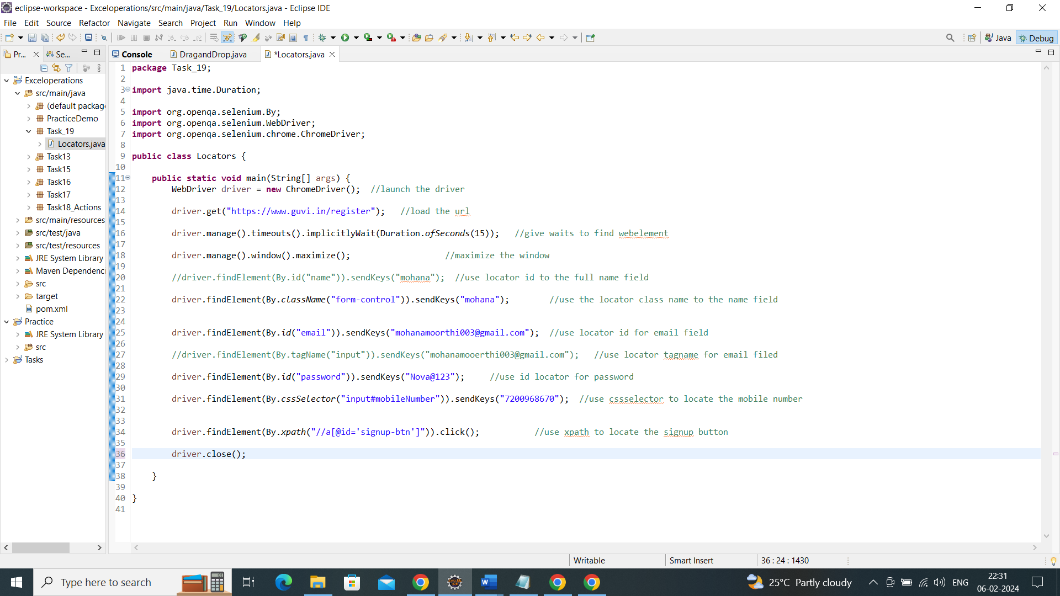

Output:

After click the signup it navigate to the next webpage.

